**Fixing MSDTC issue in POLDUKPD1 servers on 5/18/2023**

**Symptoms**.

* Primary replica GZEPOLDUKPD1SQ2
* Application having problems getting responses from SQL Server
* When I run dbautil.dbo.sp_whoisactive command, it has the whole bunch of sessions waiting on MSDTC resource, like below



**Assumption**: there is something wrong with MSDTC resource

**Steps to fix the issue**:

1. Checked Services console, noticed that MSDTC service was in Starting mode
2. Tried Stop, then Start service – did not help
3. Open DTC console: Component Services🡪Computers🡪My Computer🡪Distributed Transaction Coordinator🡪Local DTC and checked Properties

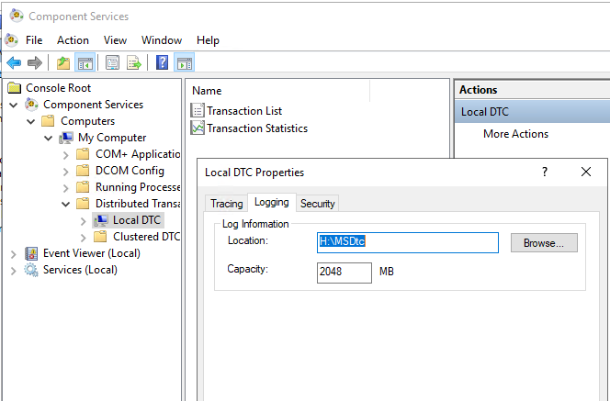

1. In Logging tab saw that service is using log at **H:\MSDtc**.
2. Realized that H: volume was rebuilt last night, thought that permissions to folder were not granted
3. In Services tab opened Distributed Transaction Coordinator:
   1. Noted that service was running off **C:\windows\System32** folder

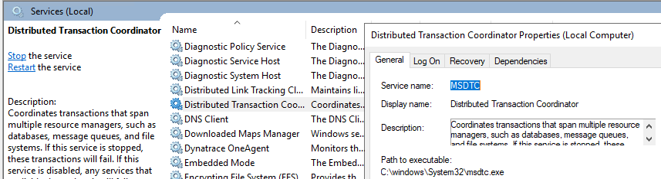

* 1. In Log On tab noticed that service is running under **Network Service**

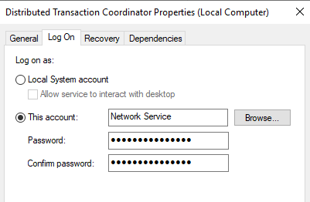

1. In Windows explorer went to H: drive and granted Full Access permissions to NETWORK SERVICE

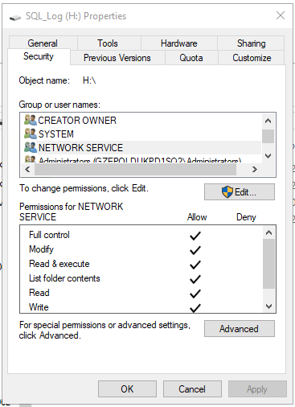

1. After granting permissions, was able to start MSDTC service
2. Application started to get responses from SQL Server
3. User complained that something is not right in Secondary GZEPOLDUKPD1SQ1 server too.
4. Assumed that we had similar issues in that replicas – missing permissions for MSDTC server

**Fixing issues in GZEPOLDUKPD1SQ1**

**Symptoms**: MSDTC service is not starting at all (different status that was observed in Primary replica – service was **Starting** there.

**Assumption**: there is different problem than we observed in Primary

**Steps to fix the issue**:

1. Checked MSDTC configuration on the server by repeating steps 3-6 above.
2. When I went to H: drive to grant permissions to NETWORK SERVICE, observed that log folder was missing

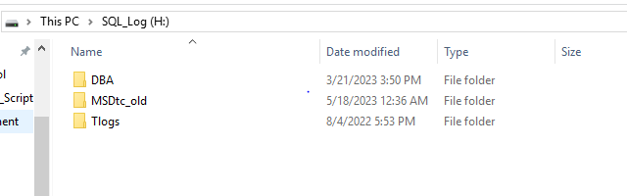

1. Created MSDTc folder that was referenced in MSDTC configuration

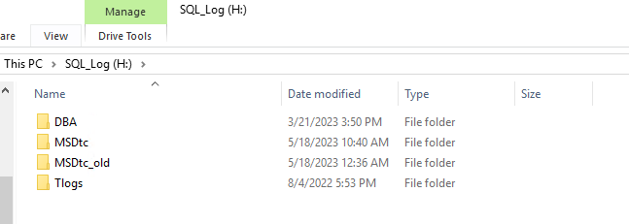

1. Granted Full access to H: drive to NETWORK SERVICE, as it was done in Primary. Service did not start.
2. Tries to reset MSDTC log by running in elevated prompt from C:\Windows\System32 by running

**msdtc -resetlog** MSDTC service did not start

1. Restarted replica. Restart did not help – service did not start.
2. Verified Event Log. In System Log discovered message below.

“Either the component that raises this event is not installed on your local computer or the installation is corrupted. You can install or repair the component on the local computer.”

This message gave me an idea that service may be corrupted when log folder was missing.

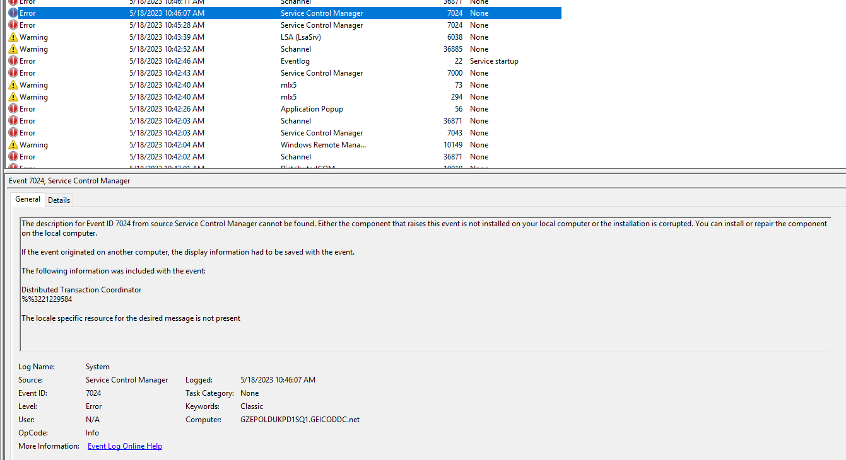

1. Checked on the web steps to reinstall MSDTC service. Found article

<https://kb.eventtracker.com/evtpass/evtpages/EventId_4162_Microsoft-Windows-MSDTC_67071.asp>

1. In elevated command prompt executed :

**msdtc -uninstall**

Observed that MSDTC service was gone from Services tab (after Refresh)

1. In elevated command prompt executed :

**msdtc -install**

Closed and re-opened Services tab, MSDTC service was running successfully.

**Fixing issues in West replicas**

**Symptoms**: In both replicas MSDTC service was running. But based on issues on East servers, verified MSDTC configuration and permissions for H: drive. Did not see any permissions for NETWORK SERVICE.

Also, did not see any new changes coming to DTSLog



**Steps to fix the issue**:

1. Granted Full Access in H: to NETWORK SERVICE
2. Reset log for MSDTC by running in elevated command prompt from C:\Windows\System32

**msdtc -resetlog** Observed changes immediately



Similar situation and fix happened in GZWPOLDUKPD1SQ3